13. Install Microsoft Office 2010 for PC
Before the installation of Microsoft Office 2010, make sure that the PC meets the systemrequirements:
● 500 MHz or higher processor
● 256 MB of RAM; 512 MB recommended
● 3.5 GB of minimum disk space
● Windows XP SP3 (supports only 32-bit Office), Vista SP1, Windows 7, Server 2003, Server2008, Server 2008
Step 1: When inserting the CD a prompt should show
Click Run SETUP.EXE
Step 2: Enter the 25 character product key on the MSU CD case and then click Continue.
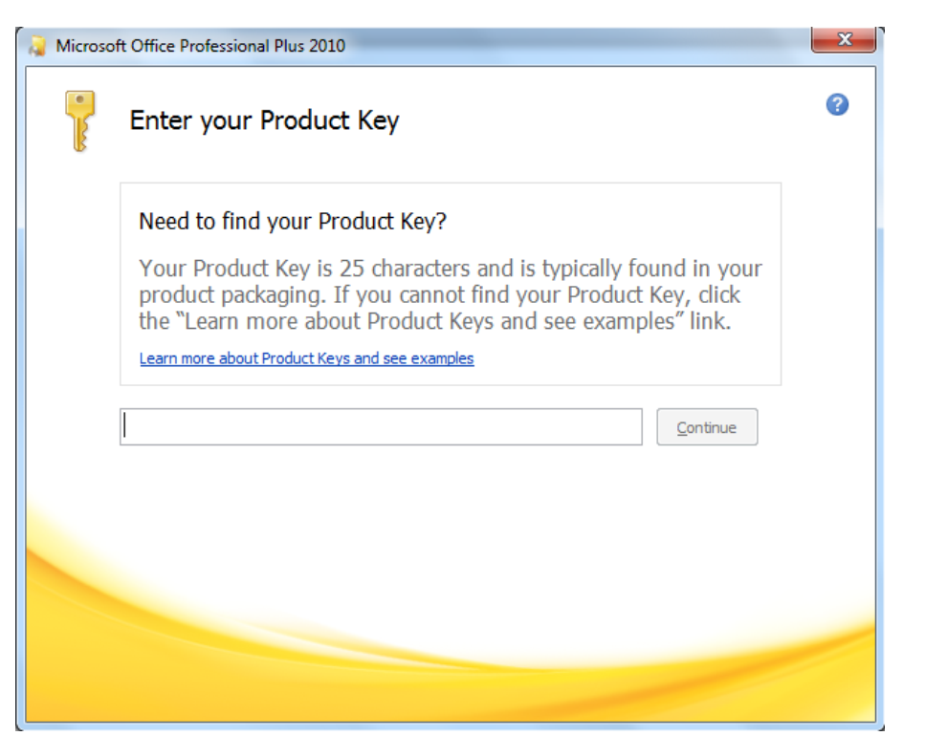
Step 3: Check the I accept the terms of this agreement box and then click Continue button to
proceed to the next step.
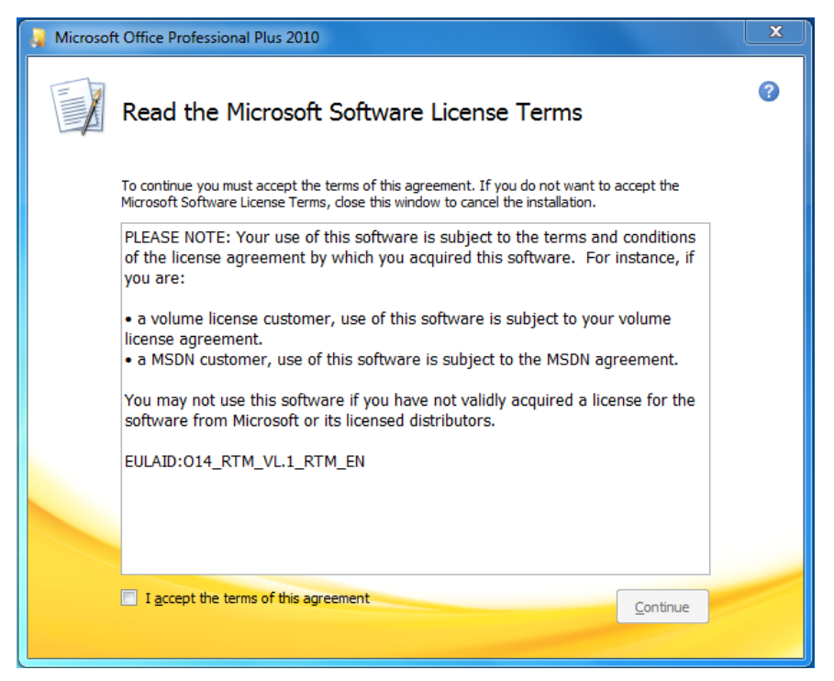
Step 4: Here, you have two options: Install Now or Customize. Clicking the Install Now button will
begin installing Office 2010 on your Windows drive.
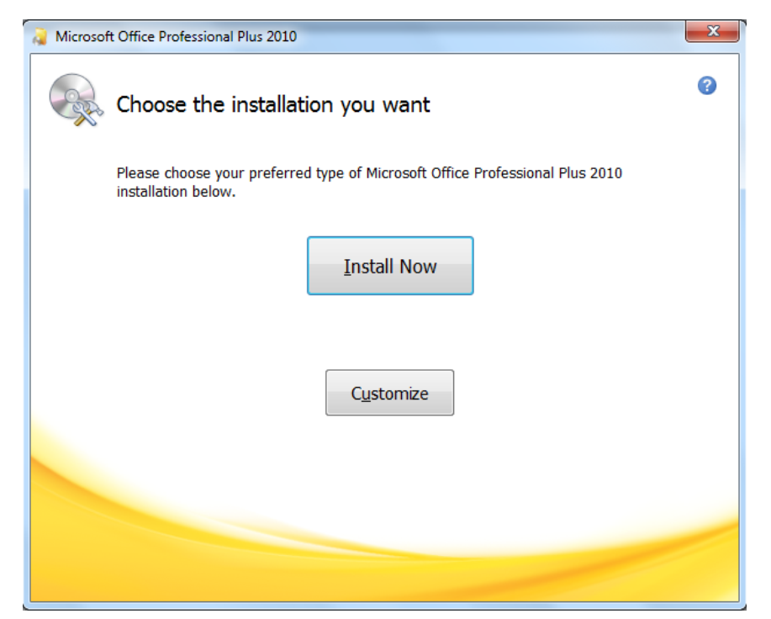
Step 5: Everything is complete and you are now able to access Microsoft Office 2010.
